**Integrated Development Environment**

1. List five main features of a software integrated development environment (IDE)

* Code
* Upload
* Serial port
* Error Checks
* Example

1. For each main feature listed in #1 above, explain the feature and how the Arduino Create environment provides this feature.

* Example- the program will give examples of other codes, work or programs
* Code- Arduino allows the user to make codes for their boards
* Error check- Arduino checks your work if it has an error in your code
* Upload
* Serial port

**Version Control System**

1. List five main features of a software version control system.

* Storage
* Sharing
* Access
* History
* Recovery

1. For each main feature listed in #3 above, explain the feature and how the GitHub environment provides this feature.

* Github stores your stuff in 1GB per repository
* You can share you repository with others
* While you can grant read/write access to collaborators on a personal repository, members of an organization can have more granular access permissions for the organization's repositories. A repository owned by a user account has two permission levels: the repository owner and collaborators.

1. Explain any version control features that we have not made use of in the class so far but that would be useful in the future.

Recovery say we are organizing our projects and we lose one, we can go and get it back. And relocate the lost file

**Programming Errors**

1. Define and explain a “syntax error” when programming code.

A syntax error is an error in the syntax of a sequence of characters or tokens that is intended to be written in a particular programming language. A program will not compile until all syntax errors are corrected.

Or

A typing error

1. Create a sample Arduino program that has a syntax error. Answer this question by copying and pasting your sample code below and by providing an explanation.

int GreenLED = 12;

int RedLED = 11;

vold setup()

{

pinMode(GreenLED, OUTPUT);

pinMode(ReadLED, OUTPUT);

}

void loop()

{

1. Define and explain a “runtime error” when programming code.

Runtime error refers to an error that takes place while executing a program.

When an issue occurs and the software is unable to solve it, it generates a runtime error.

1. Create a sample Arduino program that has a runtime error. Answer this question by copying and pasting your sample code below and by providing an explanation.

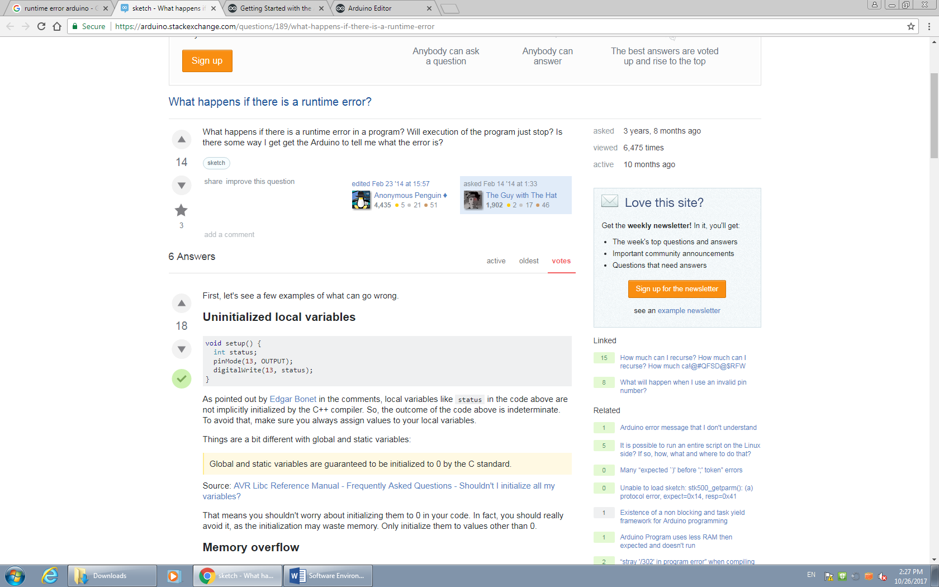

1. Define and explain a “logic error” when programming code.

A logic error is an error in a program’s source code that gives way to unanticipated and erroneous behavior. A logic error is classified as a type of runtime error that can result in a program producing an incorrect output. It can also cause the program to crash when running.

Logic errors cause a program to work incorrectly. For example, in PHP, when "if ($i=1) {…}" is incorrectly entered instead of "if ($i==1) {….},"

1. Create a sample Arduino program that has a logic error. Answer this question by copying and pasting your sample code below and by providing an explanation.

